HPV Social Media Toolkit
Feel free to add your organization’s logo alongside the Native Boost logo.

Post 1: HPV causes 6 types of cancer… And it’s sneaky! Most people don’t know they have it until it’s too late. [side eye emoji] Thankfully, we have HPV vaccines for everyone starting at age 9.

To learn more: www.IndianCountryECHO.org/Native-Boost

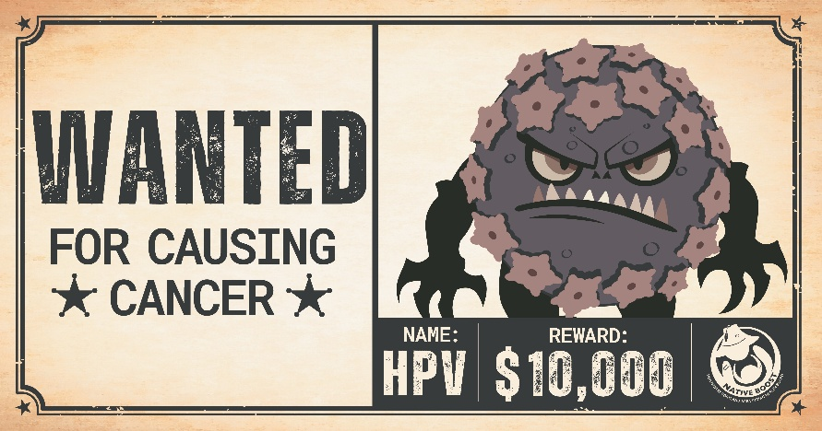
Facebook – Customize it in Canva!
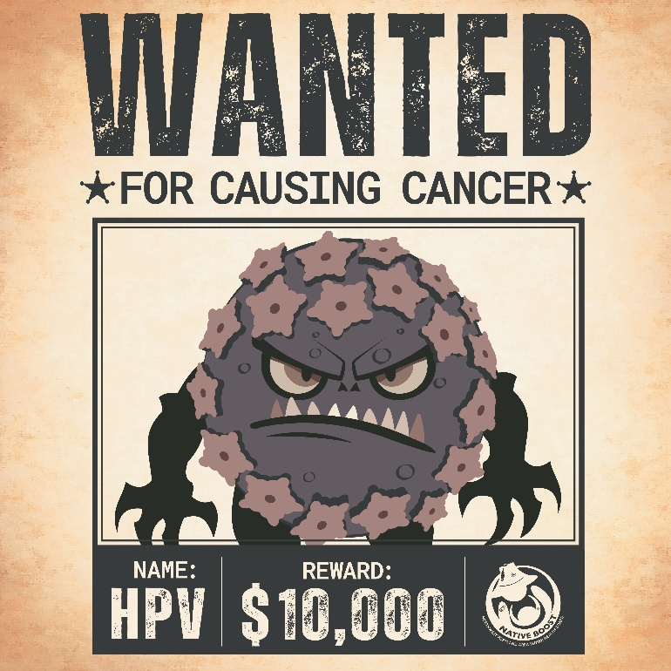
Instagram – Customize it in Canva!
Post 2: Vaccines teach our kids’ warrior cells – or antibodies - how to recognize and fight diseases. That’s why following the child vaccine schedule is very important. It ensures they are protected before they come across any dangerous diseases – like HPV.

To learn more: www.IndianCountryECHO.org/Native-Boost

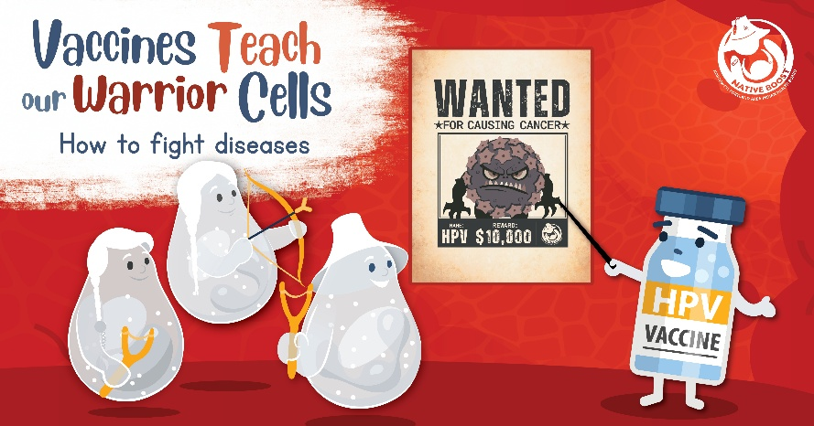
Facebook – Customize it in Canva!
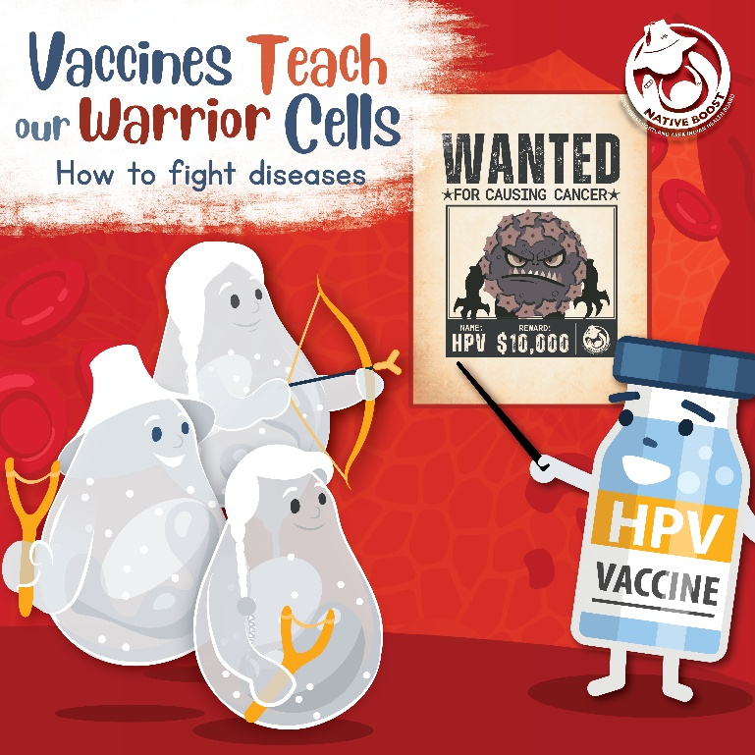
Instagram – Customize it in Canva!

Post 3:
It is recommended that kids 9-12 get the HPV vaccine - when their immune system is strongest. Then, the vaccine can prevent up to 99% of HPV-related cancers. That’s superhero level protection! [star emoji] If you your child has fallen behind with their recommended vaccinations, they can still catch up. However, missing or delaying vaccines puts your child at risk for serious illnesses.

To learn more: www.IndianCountryECHO.org/Native-Boost

Series of images:

- When to get the HPV vaccine?
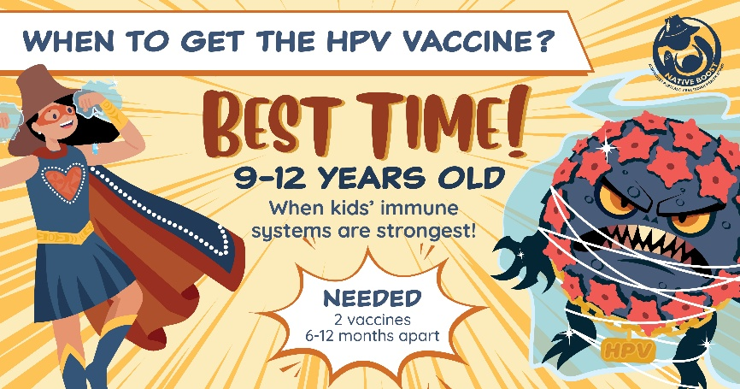
Facebook – Customize it in Canva!
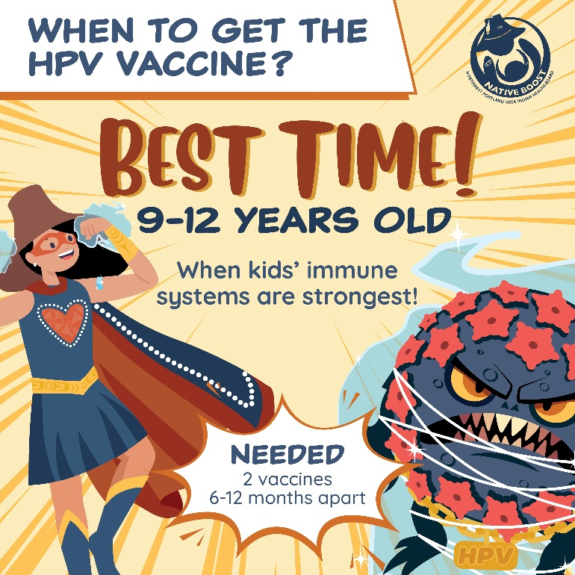
Instagram – Customize it in Canva!
- When to get the HPV vaccine?

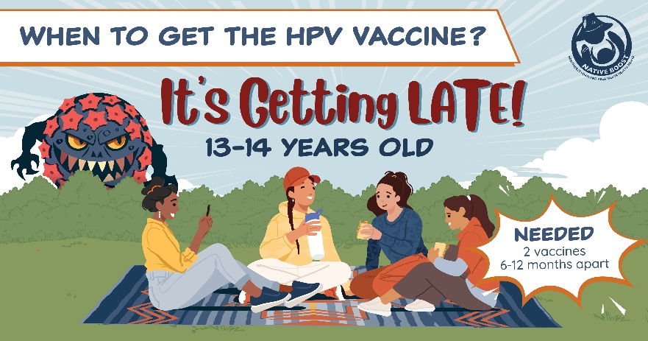
Facebook – Customize it in Canva!
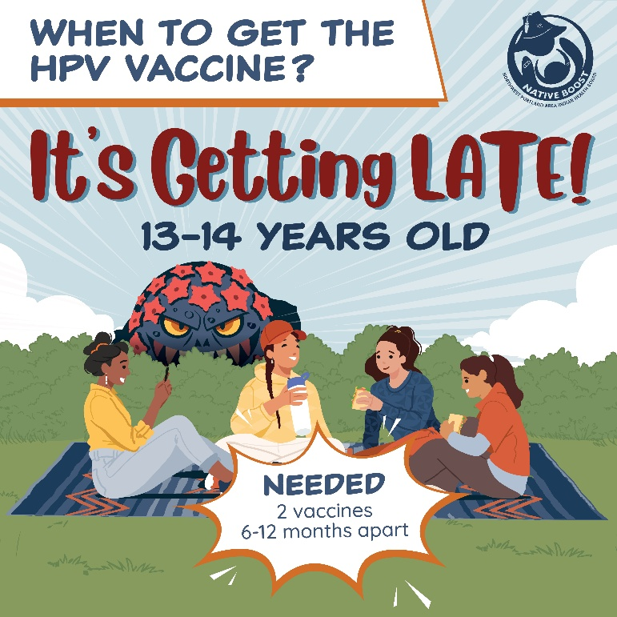
Instagram – Customize it in Canva!

- When to get the HPV vaccine?

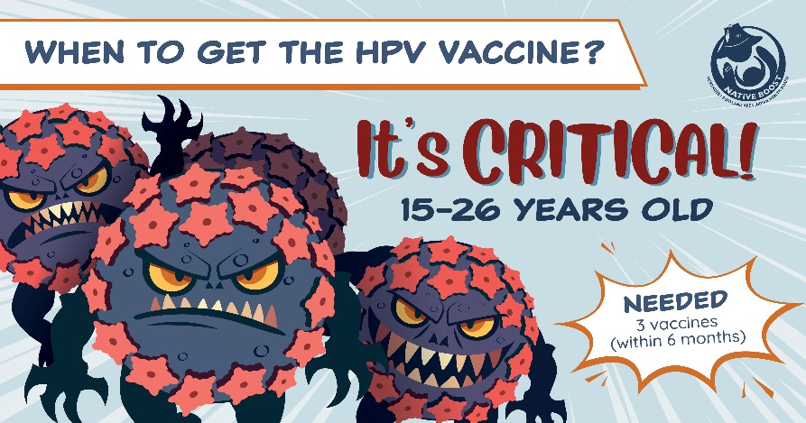
Facebook – Customize it in Canva!
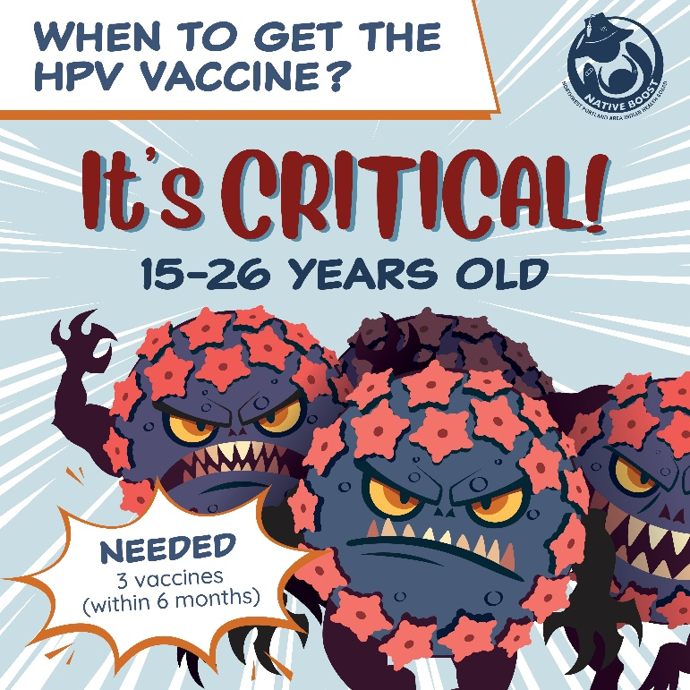
Instagram – Customize it in Canva!

Post 4:
The HPV vaccine is safe and effective for kids! [heart emoji] Over 57 million HPV vaccines have been given – many with zero side effects. If you’re nervous, remember that you are more likely to get hit by lightning than have a severe allergic reaction to any vaccine. So don’t wait. Protect your little superhero from 6 types of HPV-related cancer.

Learn more: www.IndianCountryECHO.org/Native-Boost

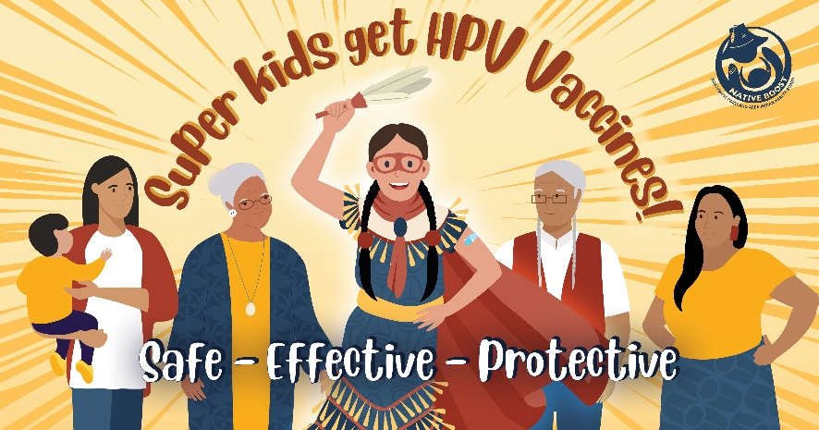
Facebook – Customize it in Canva!
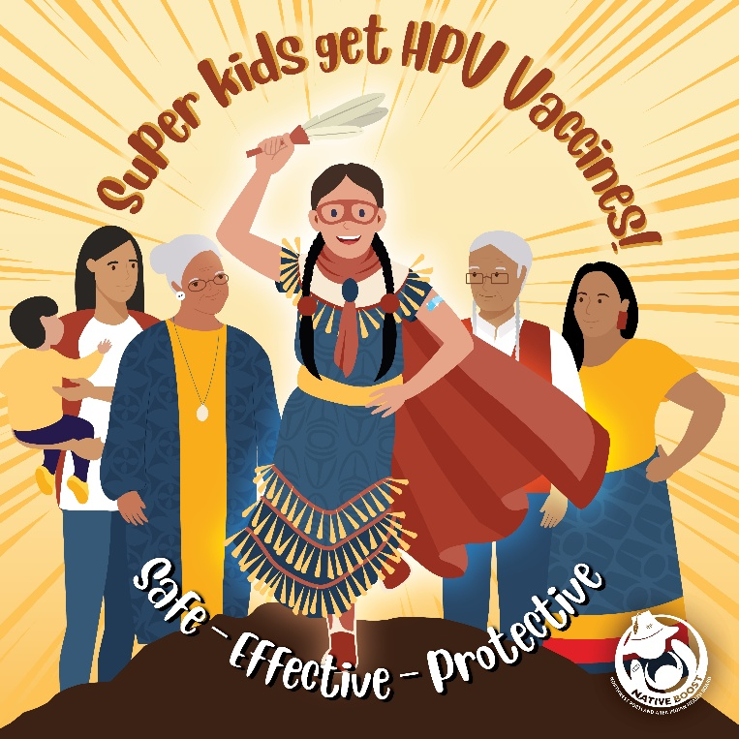
Instagram – Customize it in Canva!

Post 5: Vaccinating your child against HPV is part of doing what you can to protect them against serious illness, including certain cancers. It also makes it less likely that they get sick and spread illness to others. We are all responsible for caring for each other!

To learn more: www.IndianCountryECHO.org/Native-Boost

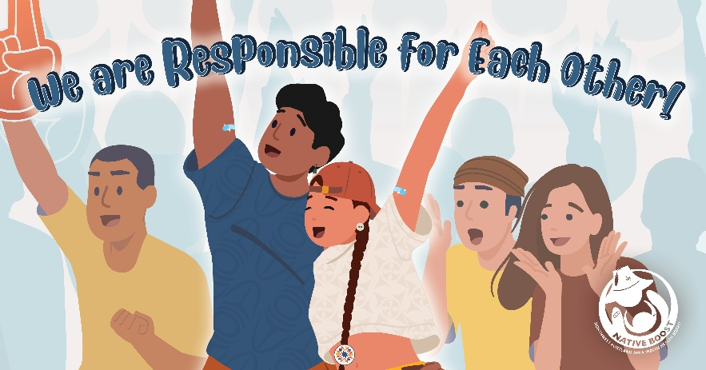
Facebook – Customize it in Canva!
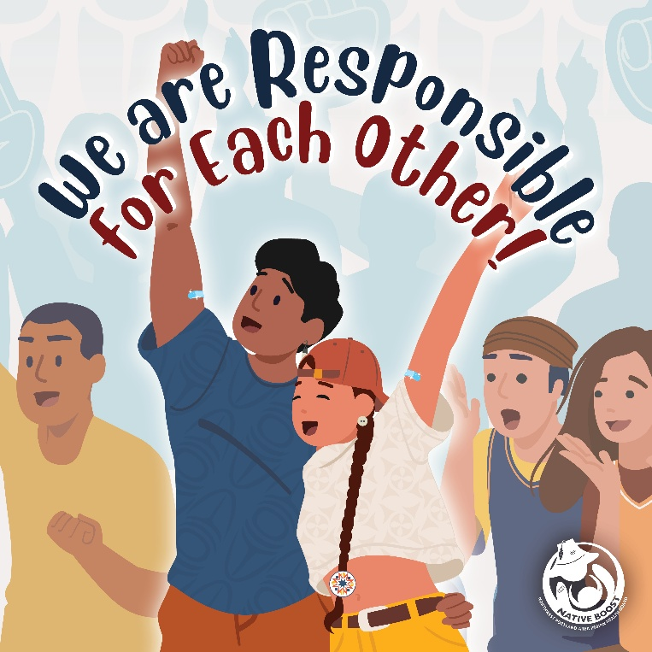
Instagram – Customize it in Canva!

Post 6: I tell parents to get their kids vaccinated when they are young – starting at age 9 – because their body is in the best position to respond strongly. The vaccine decreases their chance of getting 6 types of cancer by up to 99%.

To learn more: www.IndianCountryECHO.org/Native-Boost

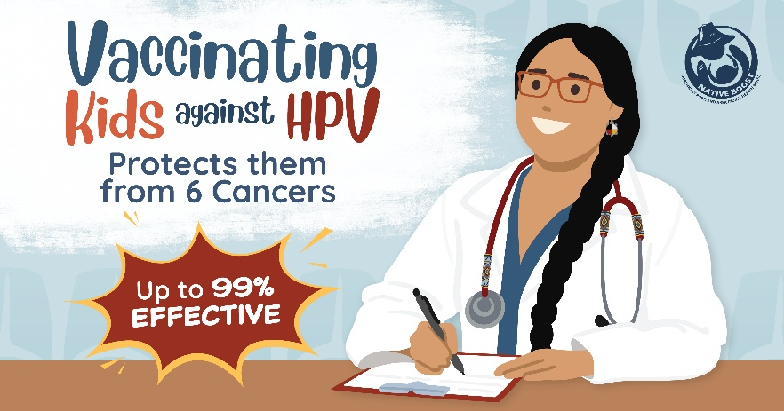
Facebook – Customize it in Canva!
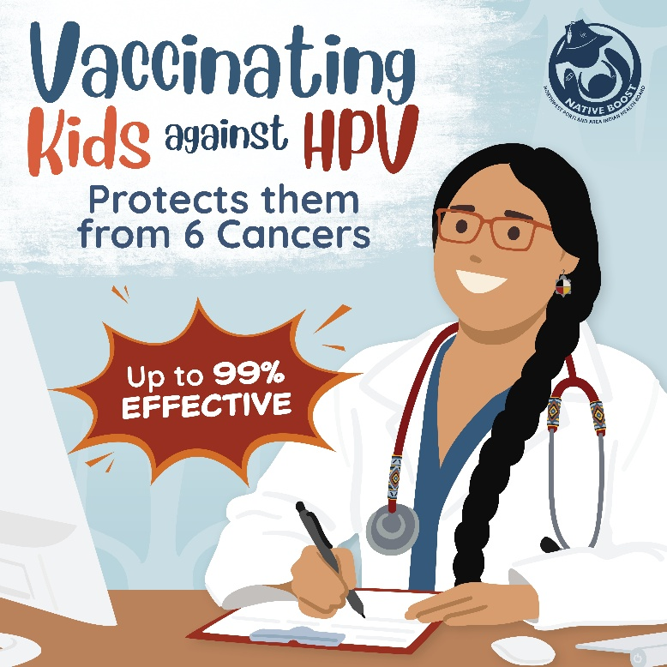
Instagram – Customize it in Canva!

