VacciNative Flu Social Media Toolkit

Feel free to add your organization’s logo alongside the VacciNative logo on each social media post.

Post 1:
The strength of our ancestors is the reason we're still here. Getting vaccinated against the flu ensures we can carry on their legacy. For accurate vaccination info for Native people by Native people, visit: www.IndianCountryECHO.org/VacciNative

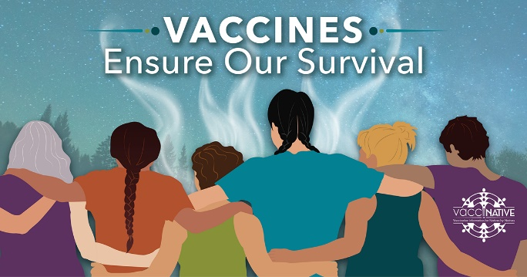
Facebook
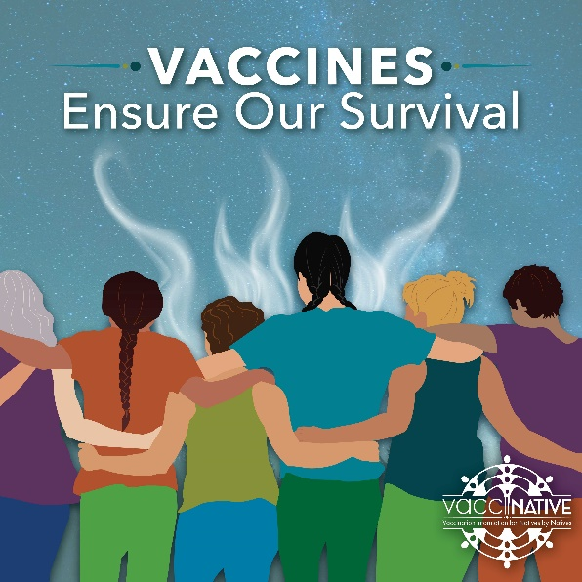
Instagram

Post 2a:
One of our strengths as Native people is that we take care of each other. Getting vaccinated against the flu helps us protect ourselves, our families, and our most vulnerable. For accurate vaccination info for Native people by Native people, visit www.IndianCountryECHO.org/VacciNative

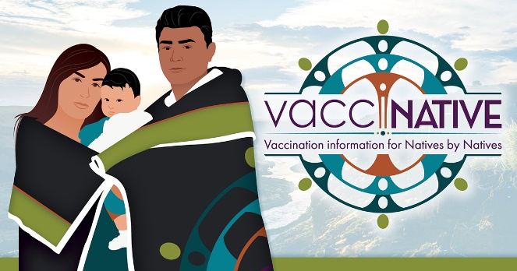
Facebook
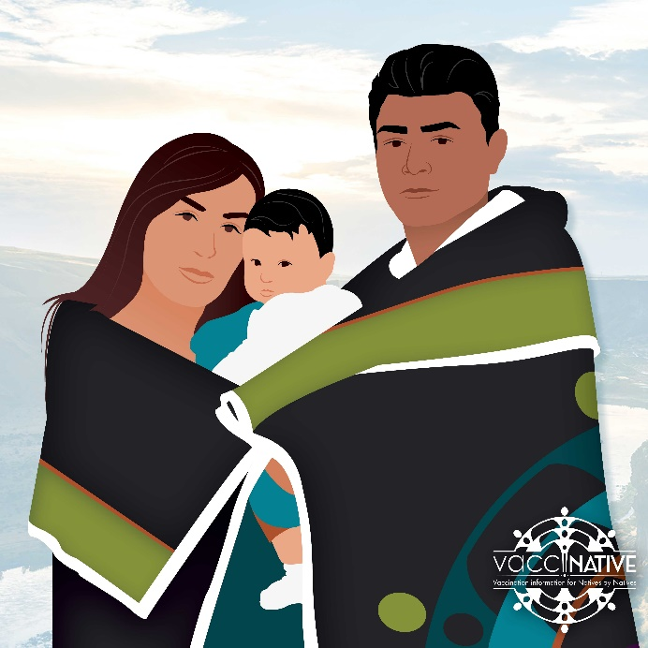
Instagram
Post 2b:
One of our strengths as Native people is that we take care of each other. Getting vaccinated against the flu helps us protect ourselves, our families, and our most vulnerable. For accurate vaccination info for Native people by Native people, visit www.IndianCountryECHO.org/VacciNative
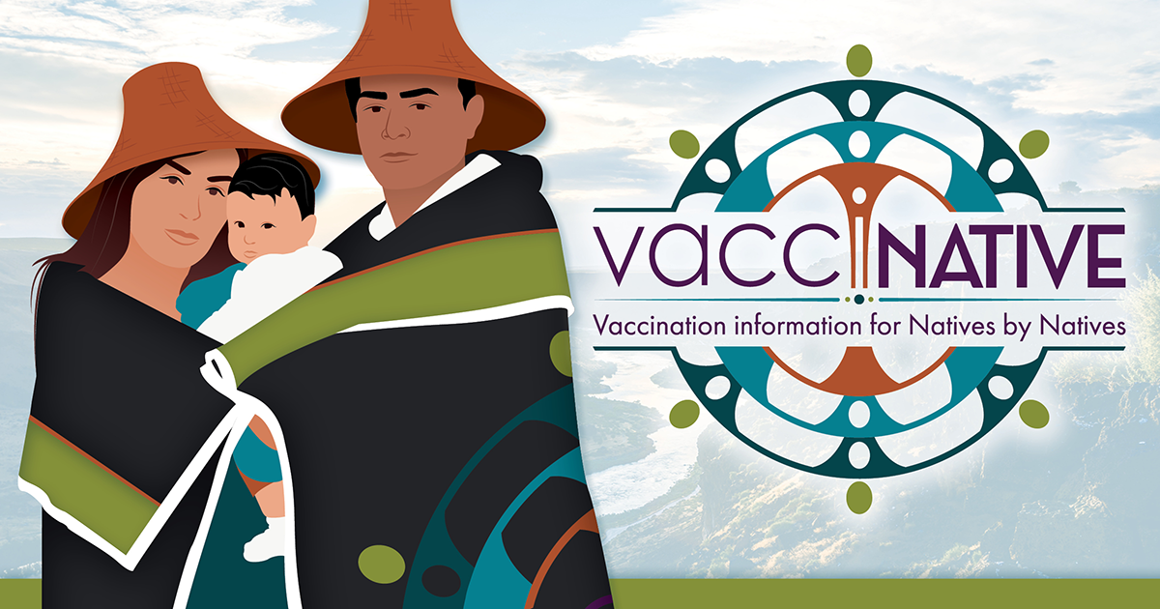
Facebook
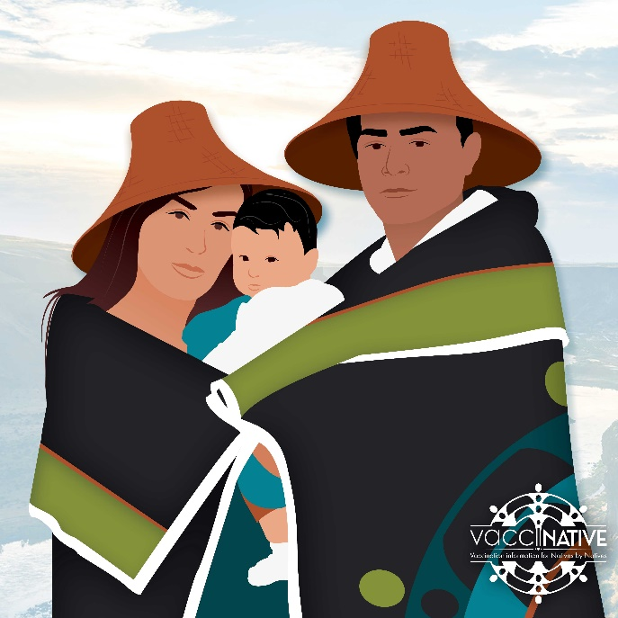
Instagram
Post 3:
Several generations ago, many died from the flu. Today the flu is still deadly-especially for our most vulnerable. However, we can protect ourselves, our family, and our community when we gather. The flu shot is safe and effective, and millions of Americans, including American Indians and Alaska Native people, have safely received the shot. Learn more here: www.IndianCountryECHO.org/VacciNative
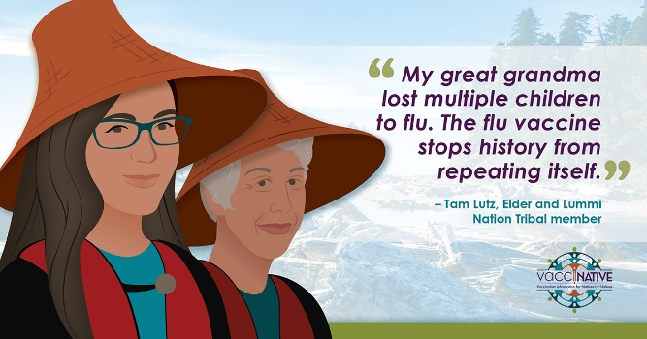
Facebook
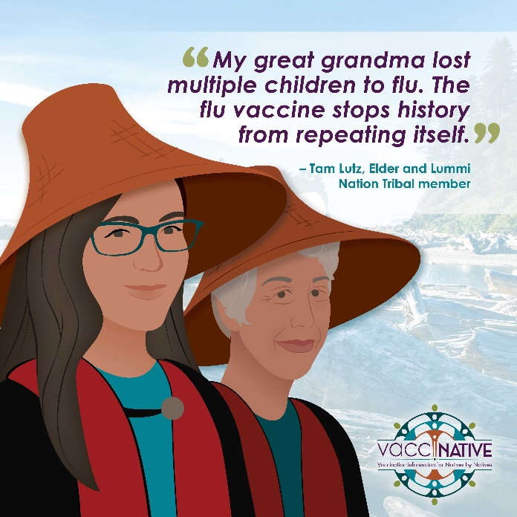
Instagram

Post 4:
“We are lost without our Elders. When we get vaccinated, we are protecting our Elderly and our culture. Even if your body is strong, it’s still important to get vaccinated.” – Lana, Elder, Crow Tribal Member. We all need to get vaccinated against the flu every year to ensure our Elders stay safe. For accurate vaccination info for Native people by Native people, visit: www.IndianCountryECHO.org/VacciNative

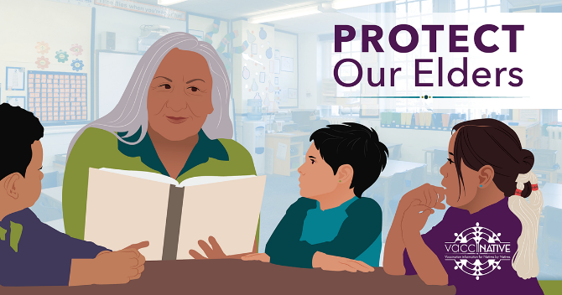
Facebook

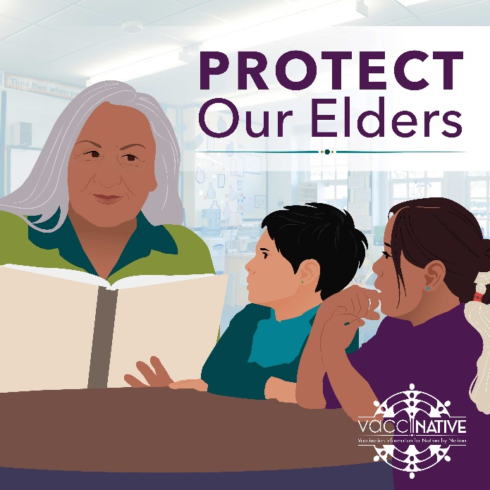
Instagram

Post 5:
“When we use traditional ways of growing plants and incorporate modern methods, like hoop houses, we're able to make sure that more of our foods and medicines are available to our people. Like the hoop houses that protect our foods and medicines, flu vaccines protect us and allow our traditions to grow.” - Dr. Lakota Scott, Diné and naturopathic doctor living in Portland, Oregon. For accurate vaccination info for Native people by Native people, visit: www.IndianCountryECHO.org/VacciNative


Facebook

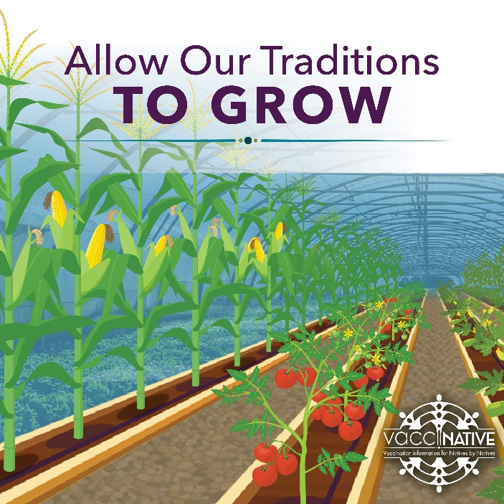
Instagram
Post 6:
We are living our ancestors’ prayers. Caring for our own and others’ physical health is a sacred act. Consider protecting what’s important by getting the flu shot. For accurate vaccination info for Native people by Native people, visit: www.IndianCountryECHO.org/VacciNative

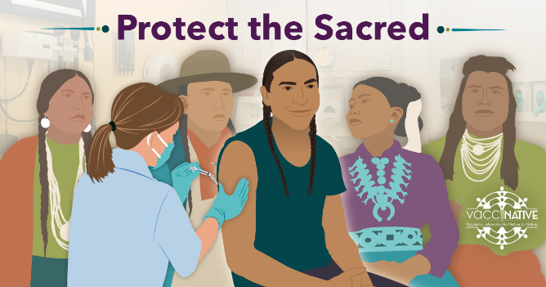
Facebook

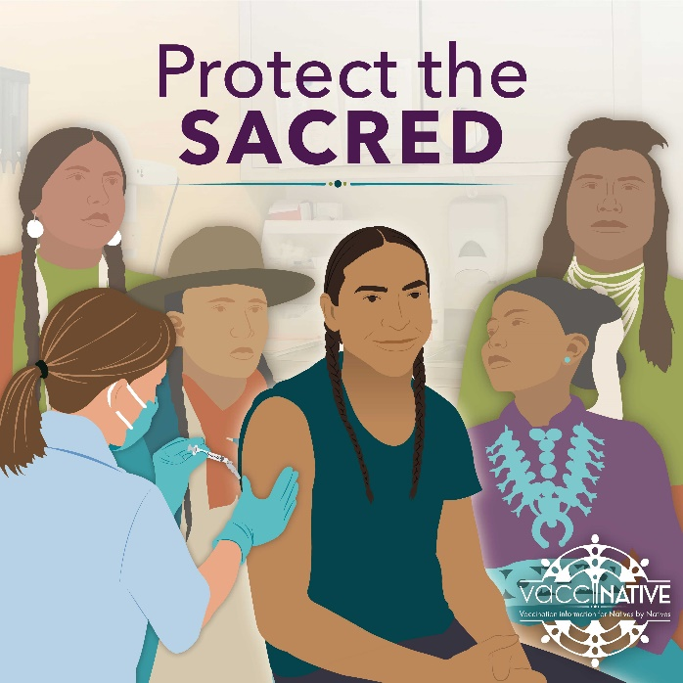
Instagram

Post 7:
Within our bodies, each of us has warrior cells that stand guard and attack diseases. When we get the flu shot, the ingredients tell our warrior cells how to recognize and fight the flu. That is why if you get a flu shot, you are less likely to get sick with the flu. It can also reduce the seriousness of illness if you happen to get sick. Get reliable vaccine info for Native people by Native people: www.IndianCountryECHO.org/VacciNative
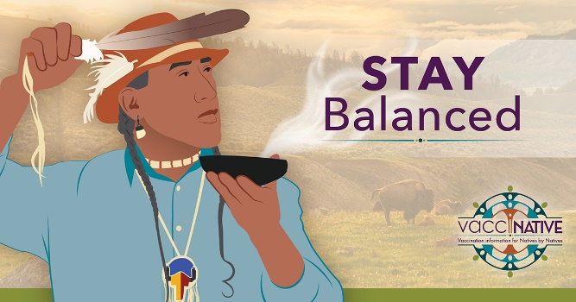
Facebook

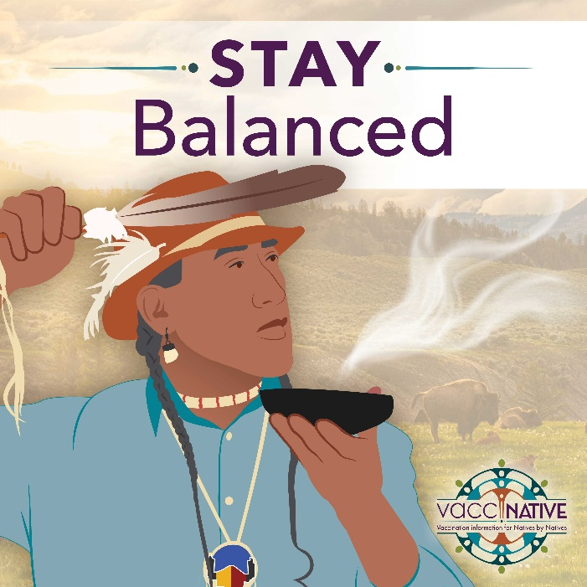
Instagram

Post 8:
Pregnant people can safely get vaccinated against flu at any time during pregnancy. For accurate vaccination info for Native people by Native people, visit: www.IndianCountryECHO.org/VacciNative
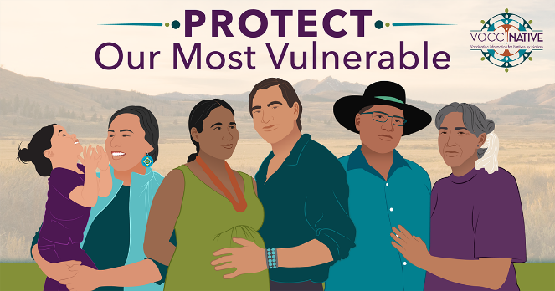
Facebook

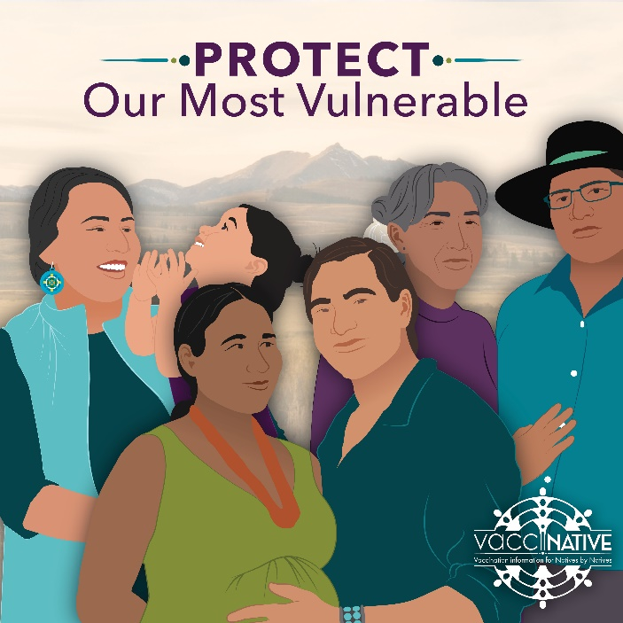
Instagram

